Website Specification Documentation

Table of Contents
The Aims & Objectives of the Website 1
Sitemap of Website 4
Page Title: Homepage 5
Page Title: Activities & Events 6
Page Title: Volunteering 7
Page Title: Contact page 8
Page Title: Reference page 9
Colour scheme & Design features 9

The Aims & Objectives of the Website
Website Topic: Kenilworth Abbey Barn Museum – Warwick (Local)

The Aim:

The key aim of the website focused on “Kenilworth Abbey Barn Museum” is to present a professional platform, that will in turn enable its end users to interface with relevant information concerning the different elements of what the museum entails.

This content will vary depending on what potential visitors searching for, such content such as what activities, tours and events will be made available to visitors on the website. On the other hand additional information will also be made available for those that wish to take upon themselves to volunteer with us. Contact data will be made accessible to the public of the organisation providing the financial backing (Kenilworth Heritage and Archaeological Society) to keep the museum operating. order to learn more about the given focus of the website.

The Target Audience:

Even though the website is accessible to anyone, this doesn’t not result in it being designed in a universal way. The audience that the website is intended for are people that share a common particular interest in the history of Kenilworth. Now from such a small preference, it would be justified to assume that those that share an intrigue in Kenilworth’s historically relevance and contents are most likely from Kenilworth themselves.

With this in mind, accommodating such users with familiar enticing language correlating to Kenilworth would likely result in them being incentivised to stay and delve deeper into what the website has to offer.
The core target audience of the website are most likely from the local area. For the sub-target audience its probable their non-locals with familial ties to the area, but never the less appropriate information will be made available leaning towards the locals.

Being aware that the target audience of the museum are locals allows for essential design considerations and information preparation. This is because simple questions presented to the audience such as “Have you ever been curious about the history of your home town” or “Come take a walk through your local land history” are able to implant the seed of curiosity in the locals minds.

Curiosity provides a great platform for enticing people to purpose different facets of reality, but it isn’t without its limitations. It’s reasonable to deduce that such a tactic may not warrant the desired response from those that derive from a non-local backgrounds.

Attempting to accommodate a universal audience that may not posses the empathy or familial ties to Kenilworth would require more coddling in order to be enticed. Factors like these are especially true if a visitor has to travel great distances to partake in such an event, it just doesn’t seem realistic.

Additionally it’s worth mentioning that the target audience of locals can fragmented into two groups, visitors and volunteers. Visitors are self explanatory for the most part, but the element of volunteers has correlation to the organisation that maintains the museum. The reason for mentioning this is because volunteers will require a slightly different amount of information that is relevant and appropriate to them when place in comparison to visitors.

Typical Websites Users:

Name: Sarah Smith    USER ONE | Details:  - Gender = Female  - Age = 51  - Interests = Spending time with family & reading  - Disabilities = Hypermetropia (Long-Sightedness)  - Background = Dinner Lady | Goals:  They would want the site to provide them with a simple interface that doesn’t require too much unnecessary clutter, but with her sight impairment seeing text may be difficult. Making text simpler to read is ideal (Font size) | Tasks:  In order to accommodate her sight impairment, a feature would be implemented into the website that would provide the user the option to adjust the text font size to their liking. (To a reasonable degree)
Name: John Goode    USER TWO | Details:  - Gender =Male  - Age = 28  - Interests = Fixing Computers, Chess & DIY Projects  - Disabilities = N/a  - Background = IT Technician | Goals:  Even though this person would probably be able to use more complicated sites, but when it comes to browsing websites for leisure they would prefer isn’t slow or buggy if used on his other devices such as a tablet & phone. | Tasks:  For ensuring that website isn’t buggy or slow thorough testing of each feature implemented will take place to ensure the best user experience.
Name: Jamie Clinton    USER THREE | Details:  - Gender = Male  - Age = 17  - Interests = Hanging out with Friends & playing video games  - Disabilities = N/a  - Background = 6th form student | Goals:  They would want the site to provide them with a somewhat colour display that isn’t bland and neutral resulting in them being disinterested in the website. | Tasks:  To meet this user requirement, consideration of the colour palette used as well as the text colouring scheme shouldn’t merge into each other or contrast too much as a result of extensive colour usage.  As an alternative to be extremely colourful the sight will have an emphasis on images.

Site Objectives:

This section will just list a few of the site objectives concerning factors such as the key features like the type of information, content and functionality that has to be implemented in order to meet the core aims of the website. Objective of Information. As the website is going to consist of 5 pages it should be relatively simpler to breakdown the key purpose of what information should be presented on each page.

When it comes to the information present on the homepage it will revolving around introducing the user to what the purpose of the website is as well as what it has to offer the user. As mentioned previously the key text correlating to Kenilworth’s locals will be used to entice its most likely users. Content such as the images being used will correlate to:

- Map of Kenilworth (Finding location of museum)
- The museum (different angles/ areas)
- Events and side attractions
- logo of financial supporter (KHAS reference)

Such content will enable the website to meet its aim by providing ensuring the users are able to get a glimpse of museum from a visual aspect. Additionally, with the use of such content the prevention of white space being wasted can occurring with the background of the page being of the museum itself.

Functionality use a mix of buttons and tiles to provide paths to the other webpages or making adaptions to the website to suite the users preference. Activities & Events, Volunteering, Contact us and Reference page will somewhat of a similar notion as the homepage, but have more of an emphasis on their specific role.

Sitemap of Website
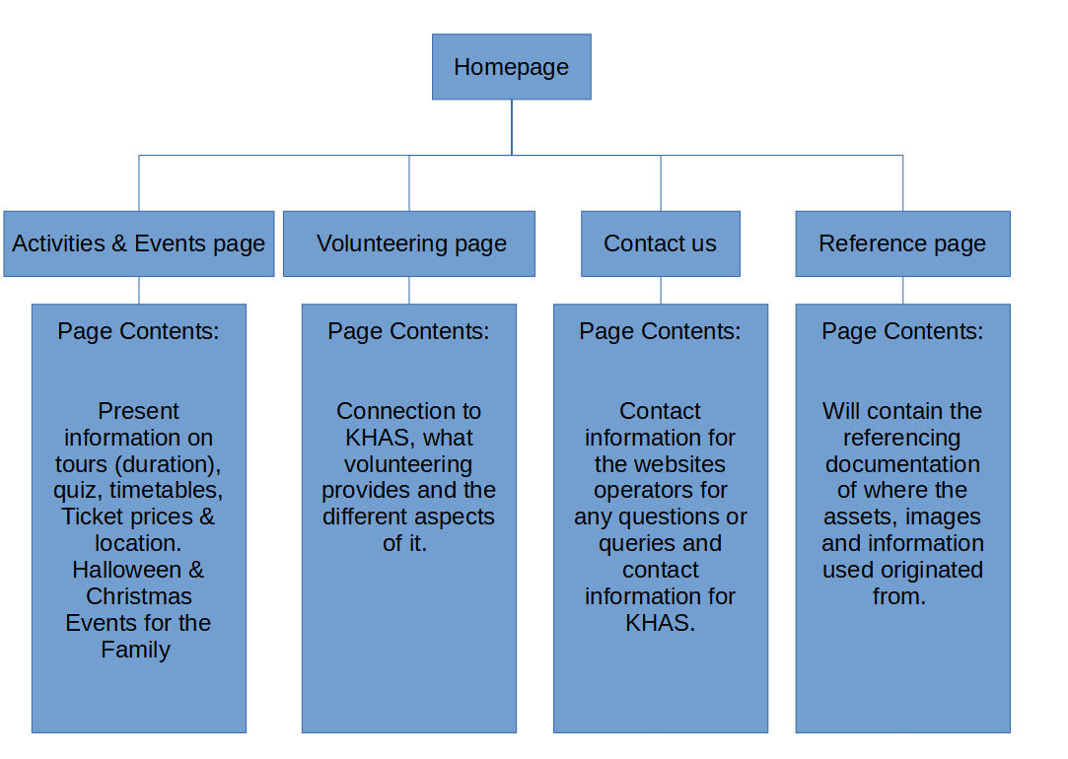

A few templates can be found below consisting of further information concerning the content that will be found on each webpage of the website in more detail as a sitemap can only convey so much information:
PAGE NAME  ___________Homepage.html  Maps to the site map page. | Page Title: Homepage
PAGE OBJECTIVE: | Provide an introduction to the user about the websites content and what it has to offer.
META DESCRIPTION  Contains about 20-25 words describing the page | The page will consist of a small introduction to what the museum is about and the organization that provides financial backing as well as volunteering opportunities.
KEYWORDS  List the primary keyword(s) first. Used by search engines | Kenilworth  Warwick  Museum  Abbey Barn
TARGET AUDIENCE | Visitors (Local)  Volunteers (Local)
USER OBJECTIVES  for page | Information acquisition of the websites purpose and what the should inspect it more as well as what is to be offered.
PAGE CONTENT  Key information requirements, | - An introduction to the page and what it presents.  - Web Title & Logo  - Buttons for page navigation.  - Tile for Volunteering summary  - Tile for Location of Museum  - Tile for Activities & Events summary
IMAGERY  Outline of supporting imagery and graphics | - Gmap of Kenilworth  - Upcoming Events (Tile Fill)  - Volunteering (Tile Fill)

PAGE NAME  __Activities&Events.html  Maps to the site map page. | Page Title: Activities & Events
PAGE OBJECTIVE: | Provide the user with all necessary information concerning the various activities and events we have to offer.
META DESCRIPTION  Contains about 20-25 words describing the page | The page will consist of key information around the tour, timetable of events, location as well as future upcoming festive events
KEYWORDS  List the primary keyword(s) first. Used by search engines | Kenilworth  Warwick  Museum  Abbey Barn  Events  Activities
TARGET AUDIENCE | Visitors (Locals)
USER OBJECTIVES  for page | Information acquisition of the Activities being held such as the quiz and upcoming events
PAGE CONTENT  Key information requirements, | - An introduction to the page and what it presents.  - Web Title & Logo  - Buttons for page navigation.  - Tile for Halloween Events  - Tile for Holiday Events  - Tile for Quiz Events  - Auto Image Roller (Alternate between 5 Images)
IMAGERY  Outline of supporting imagery and graphics | - Images of events taking place  - Halloween events  - Christmas events  - Kenilworth based Quiz  - Barn front  - Remains 1  - Remains 2  - 3D Model Presentation  - Barn Cemetery  - Background image

PAGE NAME  _______Volunteering.html  Maps to the site map page. | Page Title: Volunteering
PAGE OBJECTIVE: | Provide information to those wishing to volunteer with the museum.
META DESCRIPTION  Contains about 20-25 words describing the page | The page will consist of the volunteering opportunities that are available and if there are any requirements that need to be met as well as what you will be doing.
KEYWORDS  List the primary keyword(s) first. Used by search engines | Kenilworth  Warwick  Museum  Abbey Barn  Volunteering
TARGET AUDIENCE | Volunteers (Local)
USER OBJECTIVES  for page | Information acquisition of what is going to be taking place during the volunteering and pre-requisites.
PAGE CONTENT  Key information requirements, | - An introduction to the page and what it presents.  - Web Title & Logo  - Buttons for page navigation.  - Form to submit Volunteering application
IMAGERY  Outline of supporting imagery and graphics | - Pictures of previous volunteers  - soft skill development  - Background image  - Tick Icon  - User Icon  - Email Icon

PAGE NAME  ___________Contact page.html  Maps to the site map page. | Page Title: Contact page
PAGE OBJECTIVE: | Provide the necessary information for the users to contact different staff for varying queries.
META DESCRIPTION  Contains about 20-25 words describing the page | The page will consist of the contact information concerning visitation, IT/Website related affairs and further volunteering contact information as well as business queries.
KEYWORDS  List the primary keyword(s) first. Used by search engines | Kenilworth  Warwick  Museum  Abbey Barn  Contact  Queries
TARGET AUDIENCE | Visitors (Local)  Volunteers (Local)  Business opportunities (External)
USER OBJECTIVES  for page | Information acquisition of the relevant contact information if the website doesn’t provide enough.
PAGE CONTENT  Key information requirements, | - An introduction to the page and what it presents.  - Web Title & Logo  - Buttons for page navigation.  - Table of different staff concerning contact information
IMAGERY  Outline of supporting imagery and graphics | - Consultant asset  - Background image

PAGE NAME  __________Reference page.html  Maps to the site map page. | Page Title: Reference page
PAGE OBJECTIVE: | Provide all the appropriate referencing and sourcing of content, assets and image used in website.
META DESCRIPTION  Contains about 20-25 words describing the page | The page will consist of referencing and sourcing of content, assets and image used in website. Additionally, it will also mention why the chosen asset was used.
KEYWORDS  List the primary keyword(s) first. Used by search engines | Kenilworth  Warwick  Museum  Abbey Barn  Reference  Sourcing
TARGET AUDIENCE | Website inspector
USER OBJECTIVES  for page | Information acquisition of the referencing and sourcing of content, assets and image used.
PAGE CONTENT  Key information requirements, | - An introduction to the page and what it presents.  - Web Title & Logo  - Buttons for page navigation.  - Block of information for all the pages that used third party assets and image.
IMAGERY  Outline of supporting imagery and graphics, | - Background image

Colour scheme & Design features

Chosen Colour Scheme:

Simple collection of colours (Blue with varying mono-chromic Whites & black). This colour palette will make more sense one the final mock ups have been designed. The website isn’t intended to use a high range of colour as too much would be more appropriate for a children’s website. With the Kenilworth Abbey Barn Museum there need to be a greater level of seriousness/professionalism. As mentioned before it will be using a minimalist colour palette so there is more of an emphasis on imagery.

Wireframe Mock up of Website, Mobile & Tablet views:

Website Homepage Design
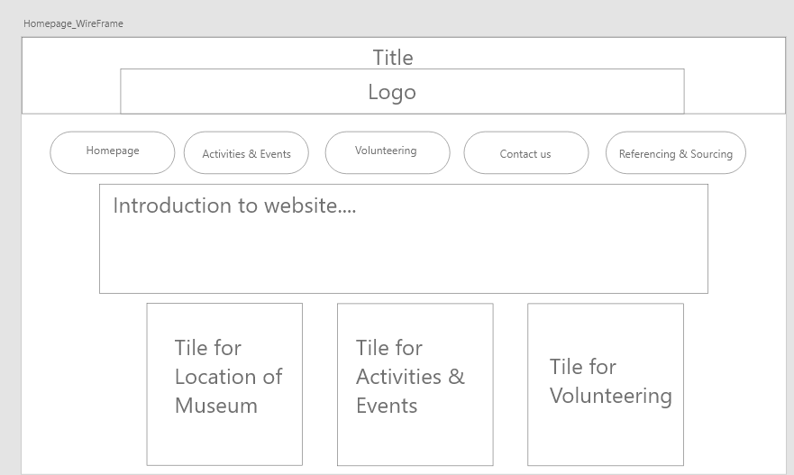
Mobile Homepage Design
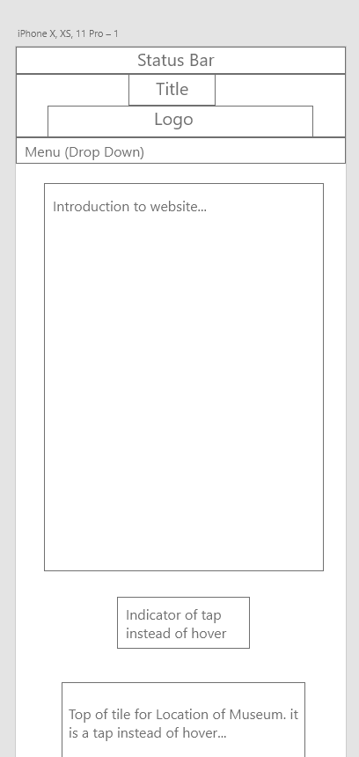

Tablet Homepage Design
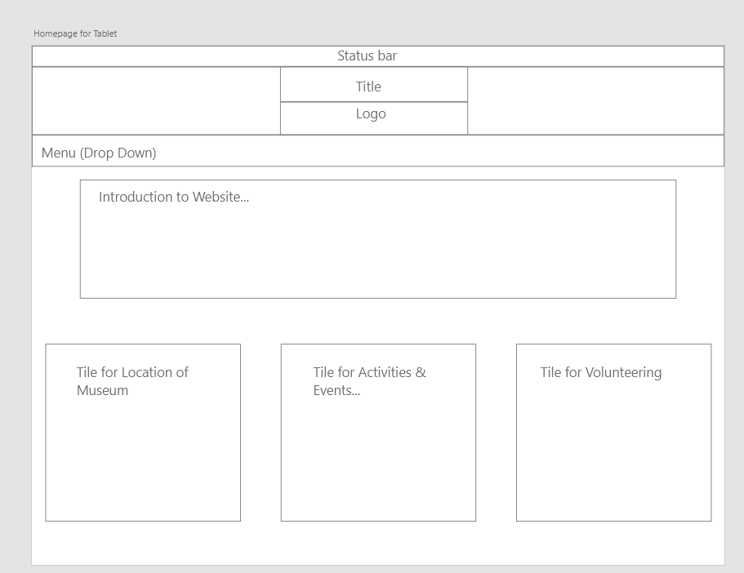

Page Design structure:

For each wire mock up design, the chosen platform that the site is displayed through uses same design for all pages on that platform, the key changed of content placement, font size, style and arrangement varies from platform to platform.

From the wireframe mock designs it’s evident the key points that were focused on were:

- Minimalistic
- To the Point
- Simple to Follow

It is minimalistic from the approach of irrelevant content, from the website homepage design it performs and presents what is intend of it. An introduction to the website with a few hover tiles to summarize some of the websites other pages. Nothing more, nothing less. Ideally the buttons should posses two behaviours being to take the user to the chosen page and perform a simple animation to indicate to the user they have chosen it (‘click me’ words appearing).

Adobe XD Mock ups

For each Adobe mock up design the given platform that the site is displayed through uses same design for all pages on that platform, the key changed of content placement, font size, style and arrangement varies from platform to platform. All the other pages will be found in the Adobe XD file.

Website Homepage Design (Menu Buttons)
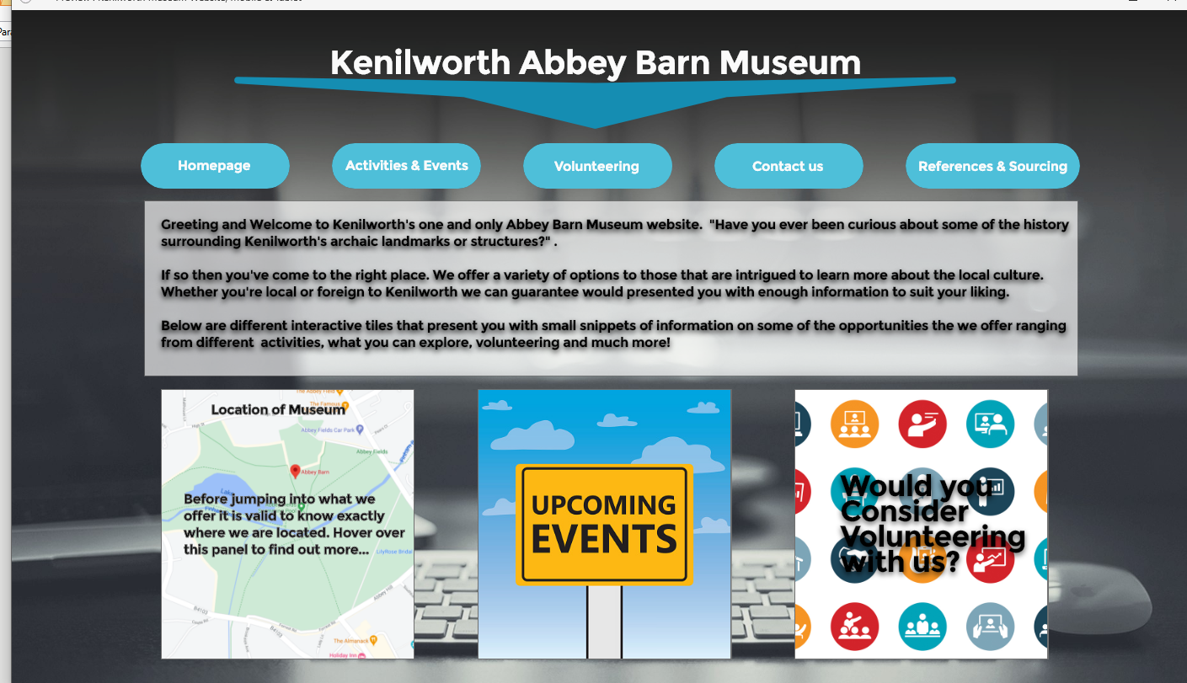

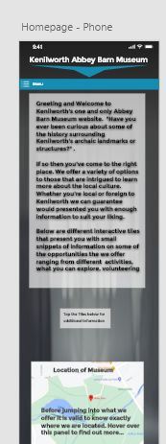
Mobile Homepage Design (Drop Down Menu)

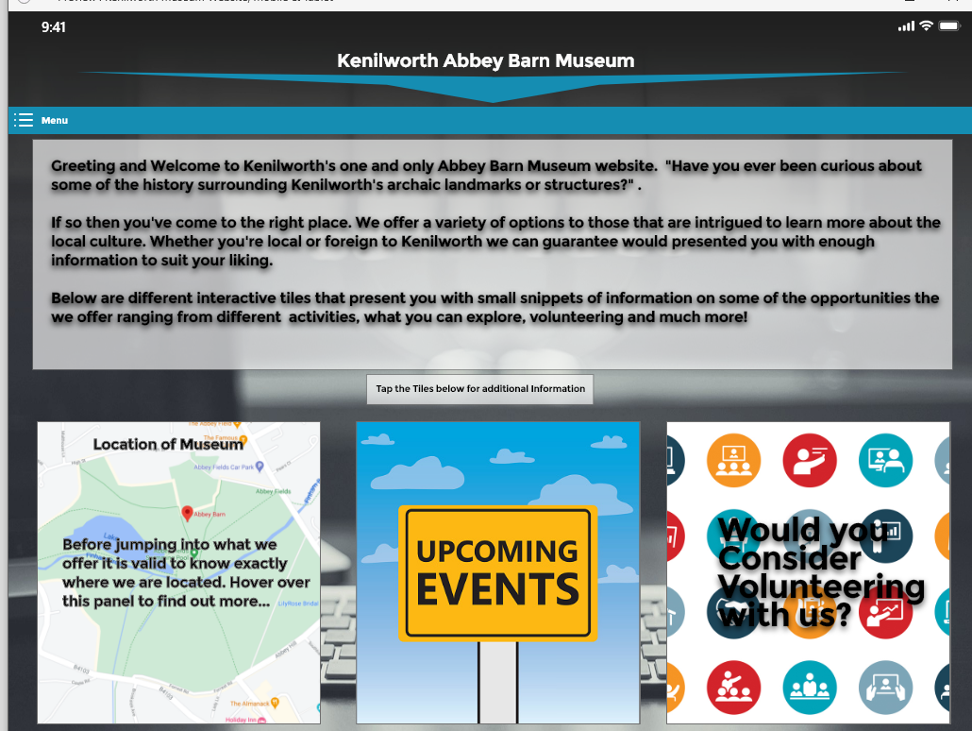
Tablet Homepage Design (Drop Down Menu)

